What is DevOps?

The DevOps is a combination of two words, one is software Development, and second is Operations. This allows a single team to handle the entire application lifecycle, from development to **testing, deployment**, and **operations**. DevOps helps you to reduce the disconnection between software developers, quality assurance (QA) engineers, and system administrators.

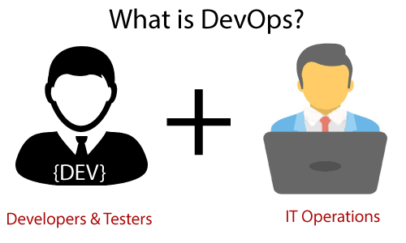

DevOps promotes collaboration between Development and Operations team to deploy code to production faster in an automated & repeatable way.

DevOps helps to increase organization speed to deliver applications and services. It also allows organizations to serve their customers better and compete more strongly in the market.

DevOps can also be defined as a sequence of development and IT operations with better communication and collaboration.

DevOps has become one of the most valuable business disciplines for enterprises or organizations. With the help of DevOps, **quality**, and **speed** of the application delivery has improved to a great extent.

DevOps is nothing but a practice or methodology of making "**Developers**" and "**Operations**" folks work together. DevOps represents a change in the IT culture with a complete focus on rapid IT service delivery through the adoption of agile practices in the context of a system-oriented approach.

DevOps is all about the integration of the operations and development process. Organizations that have adopted DevOps noticed a 22% improvement in software quality and a 17% improvement in application deployment frequency and achieve a 22% hike in customer satisfaction. 19% of revenue hikes as a result of the successful DevOps implementation.

Why DevOps?

Before going further, we need to understand why we need the DevOps over the other methods.

* The operation and development team worked in complete isolation.
* After the design-build, the testing and deployment are performed respectively. That's why they consumed more time than actual build cycles.
* Without the use of DevOps, the team members are spending a large amount of time on designing, testing, and deploying instead of building the project.
* Manual code deployment leads to human errors in production.
* Coding and operation teams have their separate timelines and are not in synch, causing further delays.

DevOps History

* In 2009, the first conference named **DevOpsdays** was held in Ghent Belgium. Belgian consultant and Patrick Debois founded the conference.
* In 2012, the state of DevOps report was launched and conceived by Alanna Brown at Puppet.
* In 2014, the annual State of DevOps report was published by Nicole Forsgren, Jez Humble, Gene Kim, and others. They found DevOps adoption was accelerating in 2014 also.
* In 2015, Nicole Forsgren, Gene Kim, and Jez Humble founded DORA (DevOps Research and Assignment).
* In 2017, Nicole Forsgren, Gene Kim, and Jez Humble published "Accelerate: Building and Scaling High Performing Technology Organizations".

DevOps Architecture Features

Here are some key features of DevOps architecture, such as:

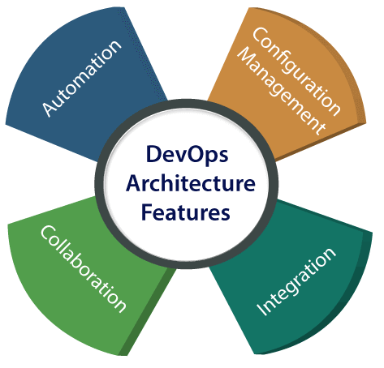

1) Automation

Automation can reduce time consumption, especially during the testing and deployment phase. The productivity increases, and releases are made quicker by automation. This will lead in catching bugs quickly so that it can be fixed easily. For contiguous delivery, each code is defined through automated tests, cloud-based services, and builds. This promotes production using automated deploys.

2) Collaboration

The Development and Operations team collaborates as a DevOps team, which improves the cultural model as the teams become more productive with their productivity, which strengthens accountability and ownership. The teams share their responsibilities and work closely in sync, which in turn makes the deployment to production faster.

3) Integration

Applications need to be integrated with other components in the environment. The integration phase is where the existing code is combined with new functionality and then tested. Continuous integration and testing enable continuous development. The frequency in the releases and micro-services leads to significant operational challenges. To overcome such problems, continuous integration and delivery are implemented to deliver in a **quicker, safer**, and **reliable manner**.

4) Configuration management

It ensures the application to interact with only those resources that are concerned with the environment in which it runs. The configuration files are not created where the external configuration to the application is separated from the source code. The configuration file can be written during deployment, or they can be loaded at the run time, depending on the environment in which it is running.

DevOps Advantages and Disadvantages

Here are some advantages and disadvantages that DevOps can have for business, such as:

Advantages

* DevOps is an excellent approach for quick development and deployment of applications.
* It responds faster to the market changes to improve business growth.
* DevOps escalate business profit by decreasing software delivery time and transportation costs.
* DevOps clears the descriptive process, which gives clarity on product development and delivery.
* It improves customer experience and satisfaction.
* DevOps simplifies collaboration and places all tools in the cloud for customers to access.
* DevOps means collective responsibility, which leads to better team engagement and productivity.

Disadvantages

* DevOps professional or expert's developers are less available.
* Developing with DevOps is so expensive.
* Adopting new DevOps technology into the industries is hard to manage in short time.
* Lack of DevOps knowledge can be a problem in the continuous integration of automation projects.

# **DevOps Architecture**

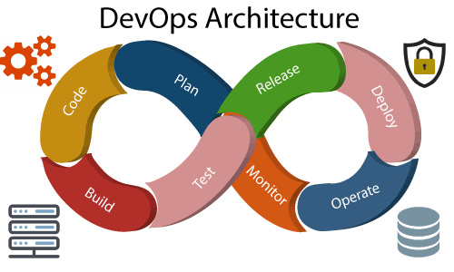

Development and operations both play essential roles in order to deliver applications. The deployment comprises analyzing the **requirements, designing, developing**, and **testing** of the software components or frameworks.

The operation consists of the administrative processes, services, and support for the software. When both the development and operations are combined with collaborating, then the DevOps architecture is the solution to fix the gap between deployment and operation terms; therefore, delivery can be faster.

DevOps architecture is used for the applications hosted on the cloud platform and large distributed applications. Agile Development is used in the DevOps architecture so that integration and delivery can be contiguous. When the development and operations team works separately from each other, then it is time-consuming to **design, test**, and **deploy**. And if the terms are not in sync with each other, then it may cause a delay in the delivery. So DevOps enables the teams to change their shortcomings and increases productivity.

Below are the various components that are used in the DevOps architecture:

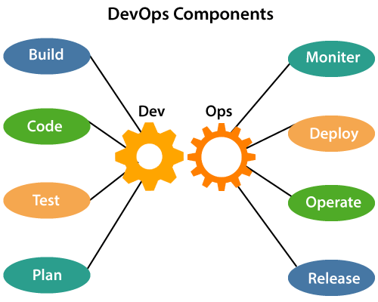

### 1) Build

Without DevOps, the cost of the consumption of the resources was evaluated based on the pre-defined individual usage with fixed hardware allocation. And with DevOps, the usage of cloud, sharing of resources comes into the picture, and the build is dependent upon the user's need, which is a mechanism to control the usage of resources or capacity.

### 2) Code

Many good practices such as Git enables the code to be used, which ensures writing the code for business, helps to track changes, getting notified about the reason behind the difference in the actual and the expected output, and if necessary reverting to the original code developed. The code can be appropriately arranged in **files, folders**, etc. And they can be reused.

### 3) Test

The application will be ready for production after testing. In the case of manual testing, it consumes more time in testing and moving the code to the output. The testing can be automated, which decreases the time for testing so that the time to deploy the code to production can be reduced as automating the running of the scripts will remove many manual steps.

### 4) Plan

DevOps use Agile methodology to plan the development. With the operations and development team in sync, it helps in organizing the work to plan accordingly to increase productivity.

### 5) Monitor

Continuous monitoring is used to identify any risk of failure. Also, it helps in tracking the system accurately so that the health of the application can be checked. The monitoring becomes more comfortable with services where the log data may get monitored through many third-party tools such as **Splunk**.

### 6) Deploy

Many systems can support the scheduler for automated deployment. The cloud management platform enables users to capture accurate insights and view the optimization scenario, analytics on trends by the deployment of dashboards.

### 7) Operate

DevOps changes the way traditional approach of developing and testing separately. The teams operate in a collaborative way where both the teams actively participate throughout the service lifecycle. The operation team interacts with developers, and they come up with a monitoring plan which serves the IT and business requirements.

### 8) Release

Deployment to an environment can be done by automation. But when the deployment is made to the production environment, it is done by manual triggering. Many processes involved in release management commonly used to do the deployment in the production environment manually to lessen the impact on the customers.

# **DevOps Lifecycle**

DevOps defines an agile relationship between operations and Development. It is a process that is practiced by the development team and operational engineers together from beginning to the final stage of the product.

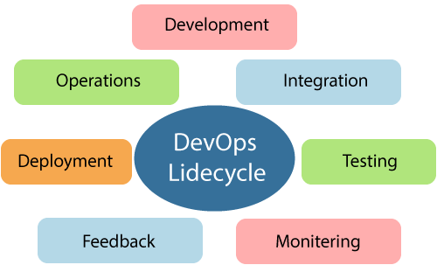

Learning DevOps is not complete without understanding the DevOps lifecycle phases. The DevOps lifecycle includes seven phases as given below:

### 1) Continuous Development

This phase involves the planning and coding of the software. The vision of the project is decided during the planning phase. And the developers begin developing the code for the application. There are no DevOps tools that are required for planning, but there are several tools for maintaining the code.

### 2) Continuous Integration

This stage is the heart of the entire DevOps lifecycle. It is a software development practice in which the developers require to commit changes to the source code more frequently. This may be on a daily or weekly basis. Then every commit is built, and this allows early detection of problems if they are present. Building code is not only involved compilation, but it also includes **unit testing, integration testing, code review**, and **packaging**.

The code supporting new functionality is continuously integrated with the existing code. Therefore, there is continuous development of software. The updated code needs to be integrated continuously and smoothly with the systems to reflect changes to the end-users.

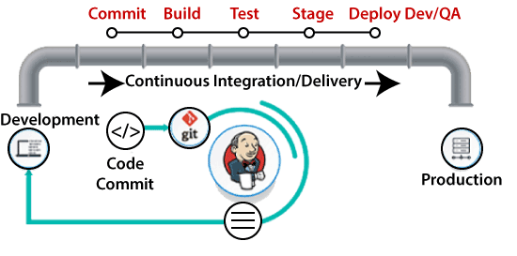

Jenkins is a popular tool used in this phase. Whenever there is a change in the Git repository, then Jenkins fetches the updated code and prepares a build of that code, which is an executable file in the form of war or jar. Then this build is forwarded to the test server or the production server.

### 3) Continuous Testing

This phase, where the developed software is continuously testing for bugs. For constant testing, automation testing tools such as **TestNG, JUnit, Selenium**, etc are used. These tools allow QAs to test multiple code-bases thoroughly in parallel to ensure that there is no flaw in the functionality. In this phase, **Docker** Containers can be used for simulating the test environment.

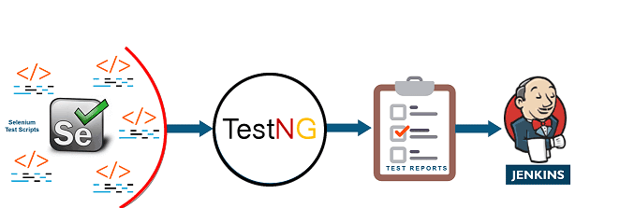

**Selenium** does the automation testing, and TestNG generates the reports. This entire testing phase can automate with the help of a Continuous Integration tool called **Jenkins**.

Automation testing saves a lot of time and effort for executing the tests instead of doing this manually. Apart from that, report generation is a big plus. The task of evaluating the test cases that failed in a test suite gets simpler. Also, we can schedule the execution of the test cases at predefined times. After testing, the code is continuously integrated with the existing code.

### 4) Continuous Monitoring

Monitoring is a phase that involves all the operational factors of the entire DevOps process, where important information about the use of the software is recorded and carefully processed to find out trends and identify problem areas. Usually, the monitoring is integrated within the operational capabilities of the software application.

It may occur in the form of documentation files or maybe produce large-scale data about the application parameters when it is in a continuous use position. The system errors such as server not reachable, low memory, etc are resolved in this phase. It maintains the security and availability of the service.

### 5) Continuous Feedback

The application development is consistently improved by analyzing the results from the operations of the software. This is carried out by placing the critical phase of constant feedback between the operations and the development of the next version of the current software application.

The continuity is the essential factor in the DevOps as it removes the unnecessary steps which are required to take a software application from development, using it to find out its issues and then producing a better version. It kills the efficiency that may be possible with the app and reduce the number of interested customers.

### 6) Continuous Deployment

In this phase, the code is deployed to the production servers. Also, it is essential to ensure that the code is correctly used on all the servers.

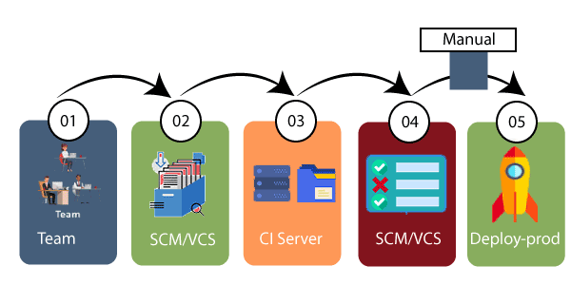

The new code is deployed continuously, and configuration management tools play an essential role in executing tasks frequently and quickly. Here are some popular tools which are used in this phase, such as **Chef, Puppet, Ansible**, and **SaltStack**.

Containerization tools are also playing an essential role in the deployment phase. **Vagrant** and **Docker** are popular tools that are used for this purpose. These tools help to produce consistency across development, staging, testing, and production environment. They also help in scaling up and scaling down instances softly.

Containerization tools help to maintain consistency across the environments where the application is tested, developed, and deployed. There is no chance of errors or failure in the production environment as they package and replicate the same dependencies and packages used in the testing, development, and staging environment. It makes the application easy to run on different computers.

### 7) Continuous Operations

All DevOps operations are based on the continuity with complete automation of the release process and allow the organization to accelerate the overall time to market continuingly.

It is clear from the discussion that continuity is the critical factor in the DevOps in removing steps that often distract the development, take it longer to detect issues and produce a better version of the product after several months. With DevOps, we can make any software product more efficient and increase the overall count of interested customers in your product.